**MODULE I**

*Introduction to parallel processing - Trends towards parallel processing - Parallelism in uniprocessor - Parallel computer structures-Architecture classification schemes – Amdahl’s law-Indian contribution to parallel processing.*

Basic concepts of parallel processing on high performance computers are introduced in this chapter. We will review the architectural evolution, examine various forms of concurrent activities in modern computer systems, and assess advanced applications of parallel processing computers.

**Definition of High Performance Computing**

High Performance Computing most generally refers to the practice of aggregating computing power in a way that delivers much higher performance than one could get out of a typical desktop computer or workstation in order to solve large problems in science, engineering, or business

**1.1 EVOLUTION OF COMPUTER SYSTEMS**

To design a powerful and cost effective computer system and to devise efficient programs to solve a computational problem, one must understand the underlying hardware and software system structures and the computing algorithms to be implemented on the machine with some user oriented programming languages. These disciplines constitute the technical scope of computer architecture. In this section we review the generations of computer systems and indicate the general trends in the development of high performance computers. Adjacent generations may overlap in several years as shown in fig 1.1



**First Generation - 1940-1956: Vacuum Tubes**

The first computers used vacuum tubes for circuitry and magnetic drums for memory, and were often enormous, taking up entire rooms. They were very expensive to operate and in addition to using a great deal of electricity, generated a lot of heat, which was often the cause of malfunctions. First generation computers relied on [machine language](http://www.webopedia.com/DidYouKnow/Hardware_Software/2002/machine_language.html) to perform operations, and they could only solve one problem at a time. Input was based on punched cards and paper tape, and output was displayed on printouts.

The UNIVAC and [ENIAC](http://www.webopedia.com/DidYouKnow/Hardware_Software/2002/ENIAC.html) computers are examples of first-generation computing devices. The UNIVAC was the first commercial computer delivered to a business client, the U.S. Census Bureau in 1951.

**Second Generation - 1956-1963: Transistors**

Transistors replaced vacuum tubes and ushered in the second generation of computers. The transistor was invented in 1947 but did not see widespread use in computers until the late 50s. The transistor was far superior to the vacuum tube, allowing computers to become smaller, faster, cheaper, more energy-efficient and more reliable than their first-generation predecessors. Though the transistor still generated a great deal of heat that subjected the computer to damage, it was a vast improvement over the vacuum tube. Second-generation computers still relied on punched cards for input and printouts for output.

Second-generation computers moved from cryptic [binary](http://www.webopedia.com/DidYouKnow/Hardware_Software/2002/binary.html) machine language to symbolic, or [assembly](http://www.webopedia.com/DidYouKnow/Hardware_Software/2002/assembly_language.html), languages, which allowed programmers to specify instructions in words. [High-level programming languages](http://www.webopedia.com/DidYouKnow/Hardware_Software/2002/high_level_language.html) were also being developed at this time, such as early versions of [COBOL](http://www.webopedia.com/DidYouKnow/Hardware_Software/2002/COBOL.html) and [FORTRAN](http://www.webopedia.com/DidYouKnow/Hardware_Software/2002/FORTRAN.html). These were also the first computers that stored their instructions in their memory, which moved from a magnetic drum to magnetic core technology. The first computers of this generation were developed for the atomic energy industry.

**Third Generation - 1964-1971: Integrated Circuits**

The development of the [integrated circuit](http://www.webopedia.com/DidYouKnow/Hardware_Software/2002/integrated_circuit_IC.html) was the hallmark of the third generation of computers. Transistors were miniaturized and placed on [silicon](http://www.webopedia.com/DidYouKnow/Hardware_Software/2002/silicon.html) [chips](http://www.webopedia.com/DidYouKnow/Hardware_Software/2002/chip.html), called [semiconductors](http://www.webopedia.com/DidYouKnow/Hardware_Software/2002/semiconductor.html), which drastically increased the speed and efficiency of computers.

Instead of punched cards and printouts, users interacted with third generation computers through [keyboards](http://www.webopedia.com/DidYouKnow/Hardware_Software/2002/keyboard.html) and [monitors](http://www.webopedia.com/DidYouKnow/Hardware_Software/2002/monitor.html) and [interfaced](http://www.webopedia.com/DidYouKnow/Hardware_Software/2002/interface.html) with an [operating system](http://www.webopedia.com/DidYouKnow/Hardware_Software/2002/operating_system.html), which allowed the device to run many different [applications](http://www.webopedia.com/DidYouKnow/Hardware_Software/2002/application.html) at one time with a central program that monitored the memory. Computers for the first time became accessible to a mass audience because they were smaller and cheaper than their predecessors.

**Fourth Generation - 1971-Present: Microprocessors**

The [microprocessor](http://www.webopedia.com/DidYouKnow/Hardware_Software/2002/microprocessor.html) brought the fourth generation of computers, as thousands of integrated circuits were built onto a single silicon chip. What in the first generation filled an entire room could now fit in the palm of the hand. The Intel 4004 chip, developed in 1971, located all the components of the computer - from the [central processing unit](http://www.webopedia.com/DidYouKnow/Hardware_Software/2002/CPU.html) and memory to input/output controls - on a single chip.

In 1981 IBM introduced its first computer for the home user, and in 1984 Apple introduced the Macintosh. Microprocessors also moved out of the realm of desktop computers and into many areas of life as more and more everyday products began to use microprocessors.

As these small computers became more powerful, they could be linked together to form networks, which eventually led to the development of the Internet. Fourth generation computers also saw the development of [GUIs](http://www.webopedia.com/DidYouKnow/Hardware_Software/2002/GUI.html), the [mouse](http://www.webopedia.com/DidYouKnow/Hardware_Software/2002/mouse.html) and [handheld](http://www.webopedia.com/DidYouKnow/Hardware_Software/2002/hand_held_computer.html) devices.

**Fifth Generation - Present and Beyond: Artificial Intelligence**

Fifth generation computing devices, based on [artificial intelligence](http://www.webopedia.com/DidYouKnow/Hardware_Software/2002/artificial_intelligence.html), are still in development, though there are some applications, such as [voice recognition](http://www.webopedia.com/DidYouKnow/Hardware_Software/2002/voice_recognition.html), that are being used today. The use of [parallel processing](http://www.webopedia.com/DidYouKnow/Hardware_Software/2002/parallel_processing.html) and superconductors is helping to make artificial intelligence a reality. [Quantum computation](http://www.webopedia.com/DidYouKnow/Hardware_Software/2002/quantum_computing.html) and molecular and [nanotechnology](http://www.webopedia.com/DidYouKnow/Hardware_Software/2002/nanotechnology.html) will radically change the face of computers in years to come. The goal of fifth-generation computing is to develop devices that respond to [natural language](http://www.webopedia.com/DidYouKnow/Hardware_Software/2002/natural_language.html) input and are capable of learning and self-organization.

**1.2 TRENDS TOWARDS PARALLEL PROCESSING**

From an application point of view, mainstream usage of computers is experiencing a trend of four ascending order of sophistication. The relationship between data, information, knowledge and intelligence are demonstrated in fig 1.2.

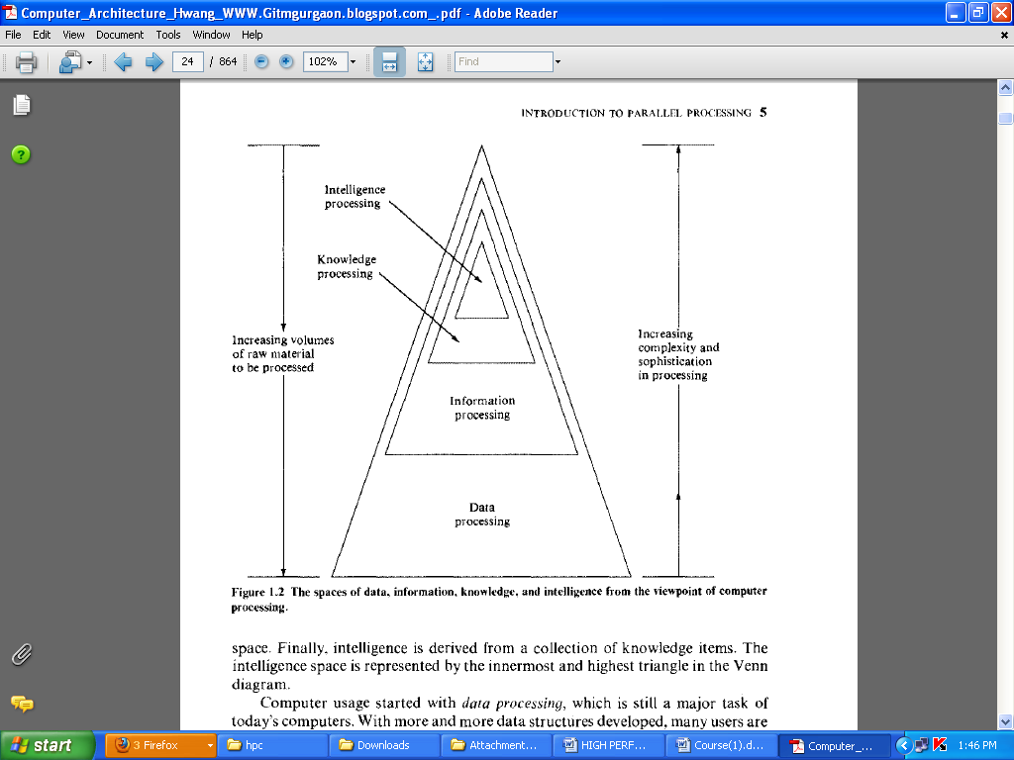

1. **Data processing**

Computer usage started with data processing, which is still a major task of today’s computers. With more and more data structures developed, many users are shifting to computer roles from pure data processing to information processing. Data space is the largest, including numeric numbers in various formats, character symbols, and multidimensional measures

1. **Information processing**

An information item is a collection of data objects that are related by some syntactic structure.Therfore information items form a subspace of data space.

1. **Knowledge processing**

Most of today’s computing is still confined within these data processing and information processing. A high degree of parallelism has been found at these levels. As the accumulated knowledge bases expanded rapidly in recent years, there grew a strong demand to use computers for knowledge processing

1. **Intelligence processing**

Today’s computers can be made very knowledgeable but are far from being intelligent .Intelligence is very difficult to create; it’s processing even more so. The degree of parallelism exploitable at the two highest processing levels should be higher than that at the data-information processing levels.

***Definition for parallel processing***

Parallel processing is an efficient form of information processing which emphasizes the exploitation of concurrent events in the computing process. Concurrently implies parallelism, simultaneity, and pipelining. Parallel events may occur in multiple resources during the same time interval; simultaneous events may occur at the same time instant; and pipelined events may occur in overlapped time spans.

Parallel processing can be challenged in four programmatic levels:

* Job or program level
* Conducted through multiprogramming , time sharing and multiprocessing.
* Requires parallel processing algorithms.ie, mainly implemented in software.
* Task or procedure level
* Involves the decomposition of a program into multiple task
* Interinstruction level
* Exploit concurrency among multiple instructions
* Data dependency analysis should be conducted to reveal parallelism
* Intrainstruction level
* Intra-Instruction parallelism is based on the observation that each instruction goes through a similar set of mutually exclusive phases
* Often implemented directly by hardware means

## *What is Parallel Computing?*

* Traditionally, software has been written for ***serial*** computation:
  + To be run on a single computer having a single Central Processing Unit (CPU);
  + A problem is broken into a discrete series of instructions.
  + Instructions are executed one after another.
  + Only one instruction may execute at any moment in time.

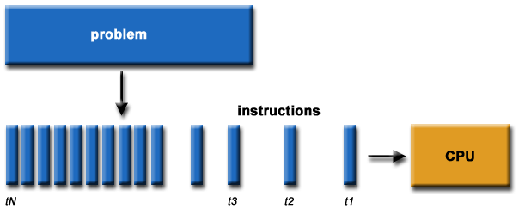

**For example:**

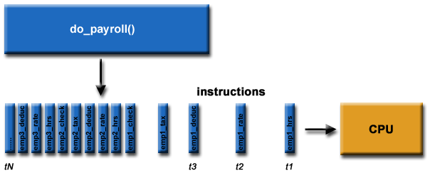

* In the simplest sense, ***parallel computing*** is the simultaneous use of multiple compute resources to solve a computational problem:
  + To be run using multiple CPUs
  + A problem is broken into discrete parts that can be solved concurrently
  + Each part is further broken down to a series of instructions
  + Instructions from each part execute simultaneously on different CPUs

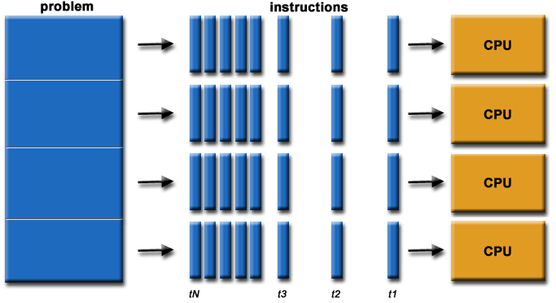

**For example:**

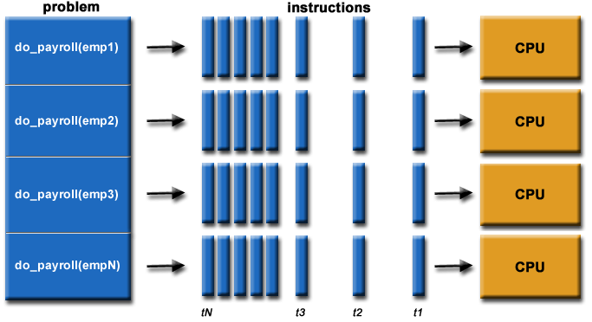

* The compute resources might be:
  + A single computer with multiple processors;
  + An arbitrary number of computers connected by a network;
  + A combination of both.
* The computational problem should be able to:
  + Be broken apart into discrete pieces of work that can be solved simultaneously;
  + Execute multiple program instructions at any moment in time;
  + Be solved in less time with multiple compute resources than with a single compute resource.

**1.3 PARALLELISM IN UNIPROCESSOR**

Most general purpose uniprocessor systems have the same basic structure. In this section we will briefly review the architecture of uniprocessor systems.

**1.3.1 BASIC UNIPROCESSOR ARCHITECTURE**

A typical uniprocessor computer consists of three major components: The main memory, CPU, I/O subsystem. Figure shows the architectural components of the super minicomputer figure 1.3 shows the architectural components of the supercomputer VAX-11/780, manufactured by Digital Equipment Company. The CPU contains the master controller of the VAX system. There are sixteen 32 bit general purpose registers, one of which serves as program counter. The CPU contains an ALU with an optional floating point accelerator, and some local cache memory with an optional diagnostic memory. The CPU can be intervened by the operator through the console connected to floppy disk.

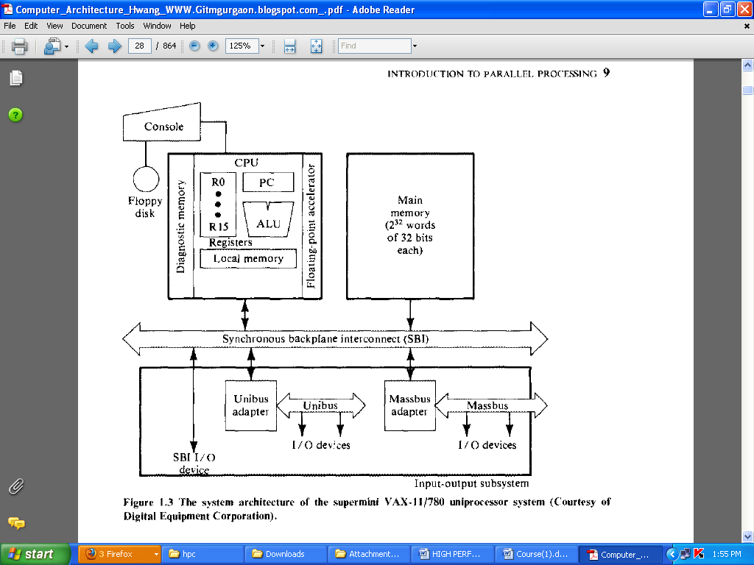

**1.3.2 PARALLEL PROCESSING MECHANISMS**

Six categories of parallel processing Mechanisms

* Multiplicity of functional units
* Parallelism and pipelining within the CPU
* Overlapped CPU and I/O operations
* Use of a hierarchical memory system
* Balancing of subsystem bandwidths
* Multiprogramming and time sharing

**Multiplicity of functional units**

The early computer had only one ALU in its CPU.ALU could only perform one function at a time, a rather slow process for executing a long sequence of arithmetic logic instructions. In practice, **many of the functions of ALU can be distributed to multiple and specialized functional units which can operate in parallel.**

The CDC-6600 has 10 functional units built in to its CPU .These 10 units are independent of each other and may operate simultaneously. A scoreboard is used to keep track of the availability of the functional units and registers being demanded.

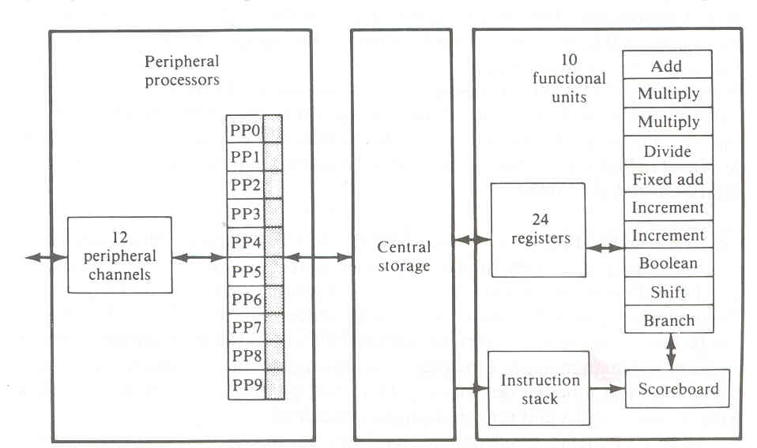

**Parallelism and pipelining within the CPU**

* Parallel adders, using techniques such as carry-look ahead and carry save are now built into almost all ALUs.
* High speed multiplier recoding and convergence division are techniques for exploring parallelism
* Sharing of hardware resources for functions of multiply and divide.
* Overlapping various phases of instruction execution alsoenhance parallelism in cpu.

**Overlapped CPU and I/O operations**

I/O operations can be performed simultaneously with the CPU computations by using separate I/O controllers, channels or I/O processors. The DMA channel can be used to provide direct information transfer between I/O devices and main memory. The DMA is conducted on a cycle stealing basis, which is apparent to the CPU.

**Use of a hierarchical memory system**

CPU is about 1000 times faster than memory access. A hierarchical memory system is used to bridge this speed gap.

In computer memory hierarchy the innermost level is the register files directly addressable by ALU. Cache memory can be used to serve as a buffer between the CPU and the main memory. Block access of main memory can be achieved through multiway interleaving across parallel memory modules. Virtual memory space can be established with the use of disks and tape units at the outer levels.

**Balancing of subsystem bandwidths**

The bandwidth of a system is defined as the number of operations performed per unit time. In the case of a main memory system, the memory bandwidth is measured by the number of memory words that can be accessed per unit time. Let W be the number of words delivered per memory cycle tm. Then the maximum memory bandwidth Bm is equal to

Bm = w (words or bytes)

tm

**Multiprogramming and time sharing**

Within the same time interval there may be multiple processes active in a computer. Competing for memory,I/O,and CPU resources. We are aware of the fact that some computer programs are cpu bound and some are I/O bound .We can mix the execution of various types of programs in the computer to balance bandwidths among the various functional units. Whenever a process P1 is tied up with I/O operations ,the system scheduler can switch the cpu to process p2.When p2 is done cpu can be switched to p3.This interleaving of CPU and I/O operations among several programs is called multiprogramming.

Time sharing:-Sometimes a high priority program may occupy the cpu for too long to allow others to share. This problem can be overcome by using a timesharing operating system.

**1.4 PARALLEL COMPUTER STRUCTURES**

Von Neumann architecture is a sequential processing machine. If we could process more than one piece of data at the same time we could speed up processing rate dramatically. This is the basis of parallel processing.

Parallel processing is the simultaneous processing of data.

Parallel computers are those systems that emphasize parallel processing. We divide parallel computers three architectural configurations:

* Pipeline computers
* Array processors
* Multiprocessor systems

**1.4.1 PIPELINE COMPUTERS**

Pipeline computer performs overlapped computations to exploit temporal parallelism.

Instruction execution involves four major steps: Instruction fetch(IF),Instruction decode (ID), Operand Fetch(OF) and Instruction Execution(EX).In a non pipelined computer , these steps must be completed before next instruction. In a pipelined computer successive instructions are executed in an overlapped fashion.

In [computing](http://en.wikipedia.org/wiki/Computing), a **pipeline** is a set of data processing elements connected in series, so that the output of one element is the input of the next one. The elements of a pipeline are often executed in parallel or in time-sliced fashion; in that case, some amount of [buffer storage](http://en.wikipedia.org/wiki/Buffer_%28computer_science%29) is often inserted between elements.

From the figure it is evident that instruction cycle is reduced to 1/4th of the original cycle time.

Theoretically, a k-stage linear pipeline processor is at most k times faster.But it is difficult to achieve ideal speed up due to memory conflicts, data dependency, branch and interrupts.

Pipelines can be of two main types:

* Instruction pipeline
* Arithmetic pipeline.

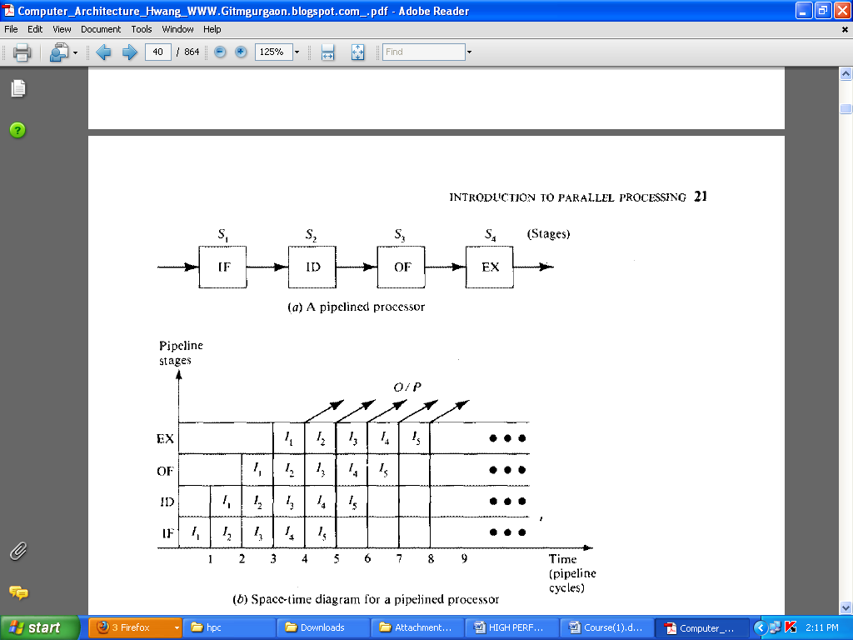

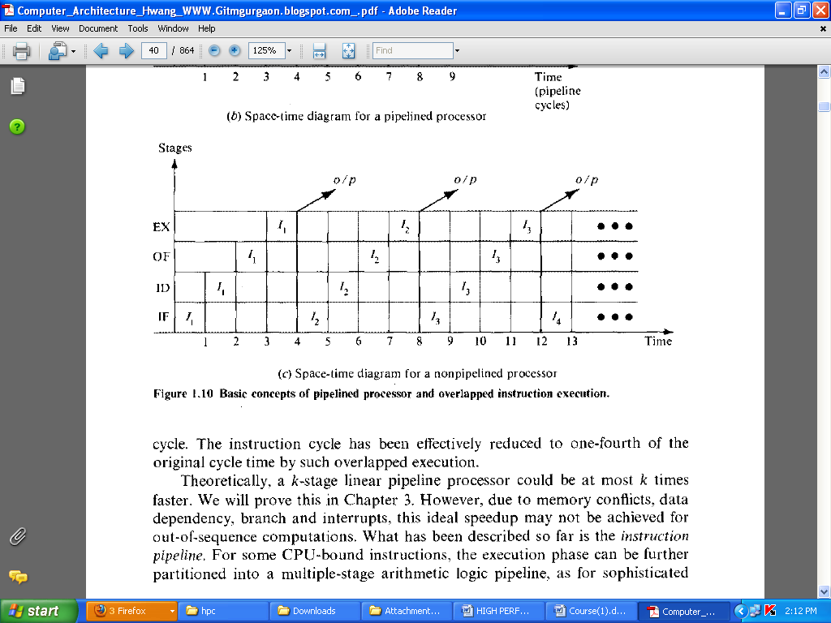

Computer-related pipelines include:

[*Instruction pipelines*](http://en.wikipedia.org/wiki/Instruction_pipeline)*,* such as the [classic RISC pipeline](http://en.wikipedia.org/wiki/Classic_RISC_pipeline), which are used in [processors](http://en.wikipedia.org/wiki/Central_processing_unit) to allow the parallel execution of two or more consecutive instructions from a nominally sequential stream; the processing elements are the logical [circuits](http://en.wikipedia.org/wiki/Electrical_network) that implement the various stages of an instruction (address decoding and arithmetic, register fetching, cache lookup, etc.).

[*Graphics pipelines*](http://en.wikipedia.org/wiki/Graphics_pipeline), found in most [graphics cards](http://en.wikipedia.org/wiki/Graphics_cards), which consist of multiple [arithmetic units](http://en.wikipedia.org/wiki/Arithmetic_and_logical_unit), or complete [CPUs](http://en.wikipedia.org/wiki/Central_processing_unit), that implement the various stages of common rendering operations ([perspective projection](http://en.wikipedia.org/wiki/Perspective_projection), window clipping, [color](http://en.wikipedia.org/wiki/Color) and [light](http://en.wikipedia.org/wiki/Light) calculation, rendering, etc.).

[*Software pipelines*](http://en.wikipedia.org/wiki/Pipeline_%28software%29), consisting of multiple [processes](http://en.wikipedia.org/wiki/Computer_process) arranged so that the output stream of one process is automatically and promptly fed as the input stream of the next one. [Unix pipelines](http://en.wikipedia.org/wiki/Pipeline_%28Unix%29) are the classical implementation of this concept

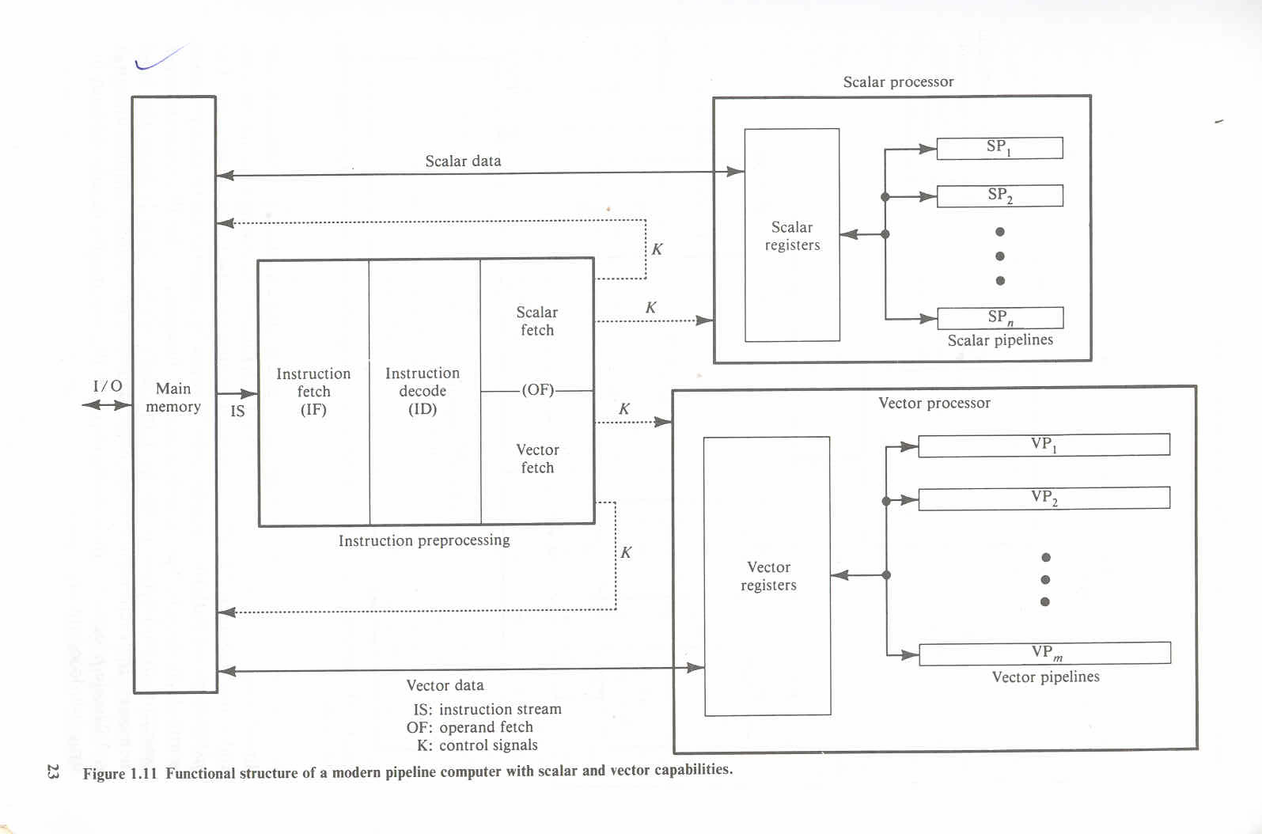

**1.4.2** **ARRAY PROCESSORS OR VECTOR PROCESSOR**

ARRAY processor is  a processor that performs computations on a large array of data.It

execute one instruction at a time but on array of data.

Consider the following example



If you want to make each coloured pixel a different color according to what it currently holds. For example "Make all Red Pixels Blue", "Make Blue Pixels Red", "Leave Green pixels alone".

A sequential processor would examine each pixel one at a time and apply the processing instruction.

But you can also arrange for data such as this to be an array. The simplest array looks like this:

{element 1, element 2, ...} this is called a '1 dimensional array' or a 'vector'

A slightly more complicated array would have rows and columns:

{element 1, element 2

element 3, element 4}

This is called a '2 dimensional' array or 'matrix'. The matrix is fundamental to graphics work.

An array processor (or vector processor) has a number of Arithmetic Logic Units (ALU) that allows all the elements of an array to be processed at the same time.

Multiple Alu’s are called processing elements(PE’s)

The illustration below shows the architecture of an array or vector processor

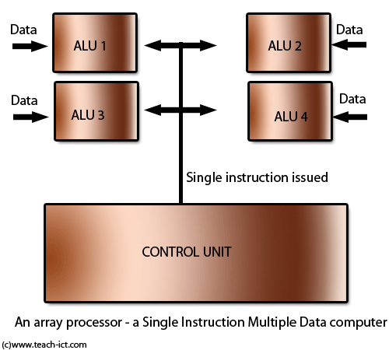

An array processor is a synchronous parallel computer with multiple arithmetic and logic unit called processing elements(PEs), that can operate in parallel.The PEs are synchronized to perform same function at same time.Common uses include analysis of fluid dynamics and rotation of 3D objects as well as data retrieval, in which elements in a database are scanned simultaneously.

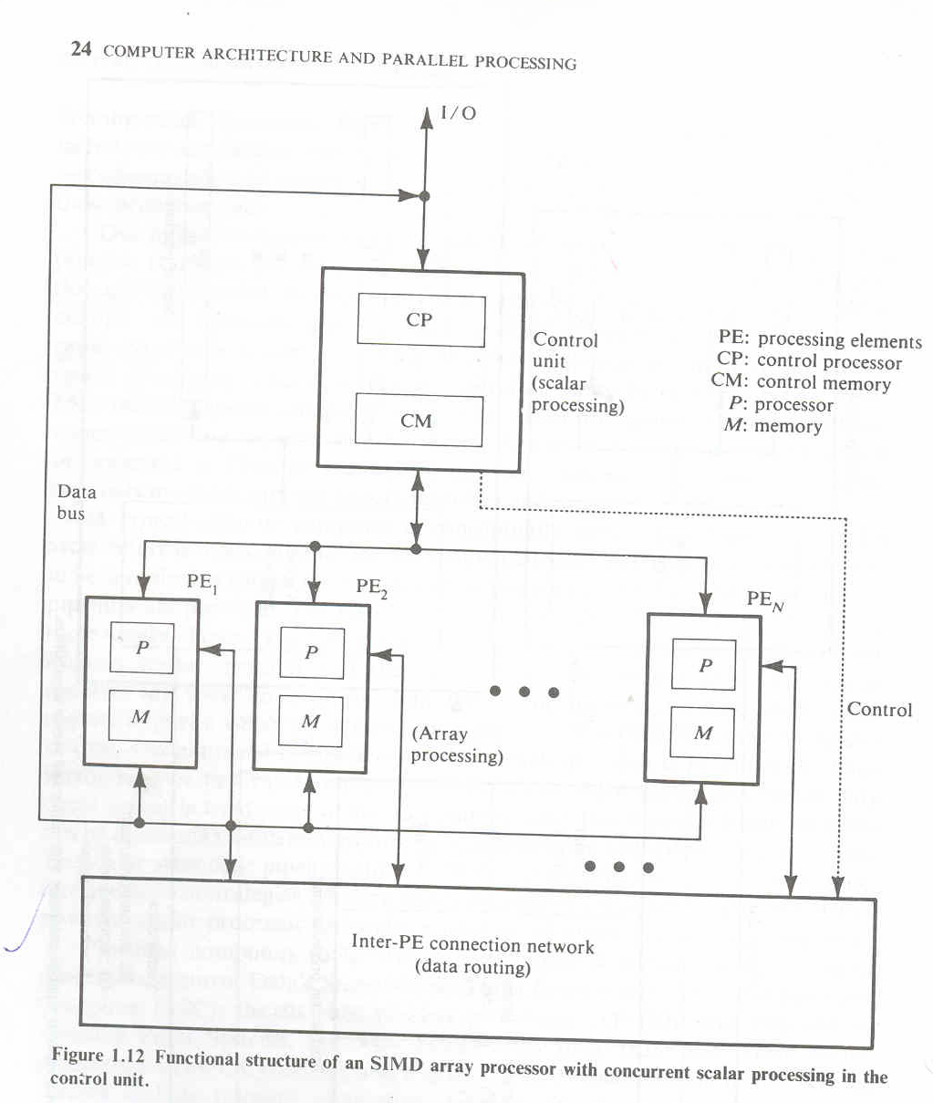

This architecture relies on the fact that the data sets are all acting on a single instruction. However, if these data sets somehow rely on each other then you cannot apply parallel processing. For example, if data A has to be processed before data B then you cannot do A and B simultaneously. This dependency is what makes parallel processing difficult to implement. And it is why sequential machines are still extremely common.

**1.4.3** **MULTIPROCESSOR SYSTEMS**

A multiprocessor system contains two or more processors of approximately comparable capabilities. All processors share access to common sets of memory modules, I/O channels and peripheral devices. Besides the shared memories and I/O devices each processor has its own local memory and private devices. Interprocessor communications can be done through the shared memories .Multiprocessor hardware system organization is determined primarily by the interconnection structure to be used between the memories and processors.

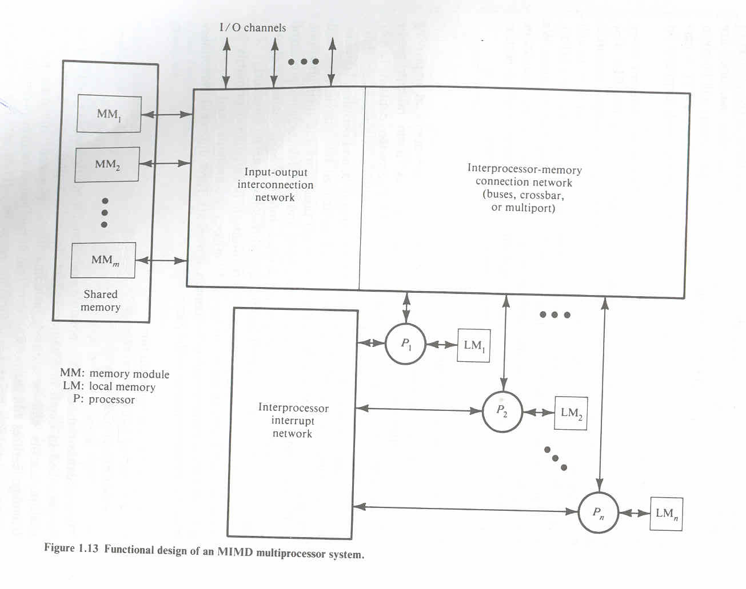

DATA FLOW COMPUTERS:



**1.5 ARCHITECTURE CLASSIFICATION SCHEMES**

There are many ways of classifying computer architectures based on their structure and behavior ie;

* Number of instructions or operand(data) sets that can be processed simultaneously
* The internal organization structure
* Interprocessor connection structure
* Methods used to control the flow of instructions and data through the system.

There are mainly three computer architectural classification schemes.

* **Flynn’s classification** is based on the multiplicity of instruction streams and data streams in a computer system.
* **Feng’s scheme** is based on serial versus parallel processing.
* **Handler’s classification** is determined by the degree of parallelism and pipelining in various subsystem levels.

**1.5.1 FLYNN’S CLASSIFICATION(Multiplicity Of Instruction-Data Streams)**

* First studied and proposed by Michael J Flynn.
* Introduced the concept of instruction and data streams for categorizing of computers.

CPU operates by fetching instructions and operands, from main memory , executing the instructions and placing the results in main memory. This complete sequence is known as instruction cycle.

## ****Instruction Stream and Data Stream:-****

The term ‘stream’ refers to a sequence or flow of either instructions or data operated on by the computer. In the complete cycle of instruction execution, a flow of instructions from main memory to the CPU is established. This flow of instructions is called instruction stream. Similarly, there is a flow of operands between processor and memory bi-directionally. This flow of operands is called data stream; a data stream is a sequence of data including input, partial, or temporary results, called for by the instruction stream



Digital computers may be classified in to 4 categories, according to the multiplicity of hardware provided to service instruction and data streams.

• Flynn’s taxonomy distinguishes multi-processor computer architectures according to how they can be classified along the two independent dimensions of ***Instruction*** and ***Data***. Each of these dimensions can have only one of two possible states: ***Single*** or ***Multiple***.

• The matrix below defines the 4 possible classifications according to Flynn:

|  |  |
| --- | --- |
| S I S D **Single Instruction, Single Data** | S I M D **Single Instruction, Multiple Data** |
| M I S D **Multiple Instruction, Single Data** | M I M D **Multiple Instruction, Multiple Data** |

**1 Single Instruction, Single Data** (**SISD) computer organization**

In this organisation, sequential execution of instructions is performed by one CPU containing a single processing element (PE), i.e., ALU under one control unit

SISD machines are conventional serial computers that process only one stream of instructions and one stream of data. An SISD computer may have more than one functional unit in it. All the functional units are under supervision of one control unit.



Fig: *SIMD COMPUTER*

* A serial (non-parallel) computer
* **Single Instruction:** Only one instruction stream is being acted on by the CPU during any one clock cycle
* **Single Data:** Only one data stream is being used as input during any one clock cycle
* Deterministic execution
* This is the oldest and even today, the most common type of computer
* Examples: older generation mainframes, minicomputers and workstations; most modern day PCs.

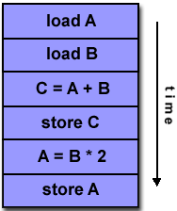 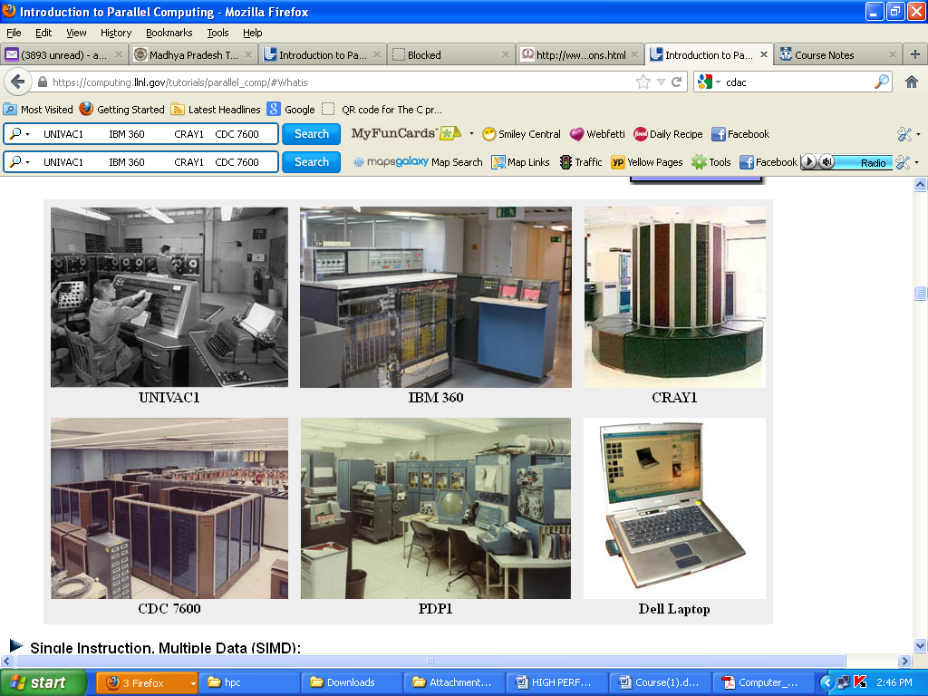

**2** **Single Instruction, Multiple Data (SIMD) computer organization**

This corresponds to array processors. Here multiple processing elements supervised by the same control unit. All PUs receive the same instruction broadcast from the control unit but operate on different data sets from distinct data streams.

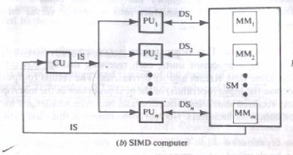

* A type of parallel computer
* **Single Instruction:** All processing units execute the same instruction at any given clock cycle
* **Multiple Data:** Each processing unit can operate on a different data element
* Best suited for specialized problems characterized by a high degree of regularity, such as graphics/image processing.
* Two varieties: Processor Arrays and Vector Pipelines
* Examples:
  + Processor Arrays: Connection Machine CM-2, MasPar MP-1 & MP-2, ILLIAC IV
  + Vector Pipelines: IBM 9000, Cray X-MP, Y-MP & C90, Fujitsu VP, NEC SX-2, Hitachi S820, ETA10
* Most modern computers, particularly those with graphics processor units (GPUs) employ SIMD instructions and execution units.

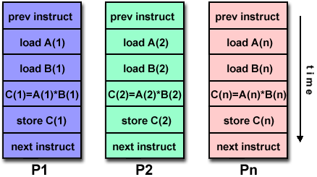

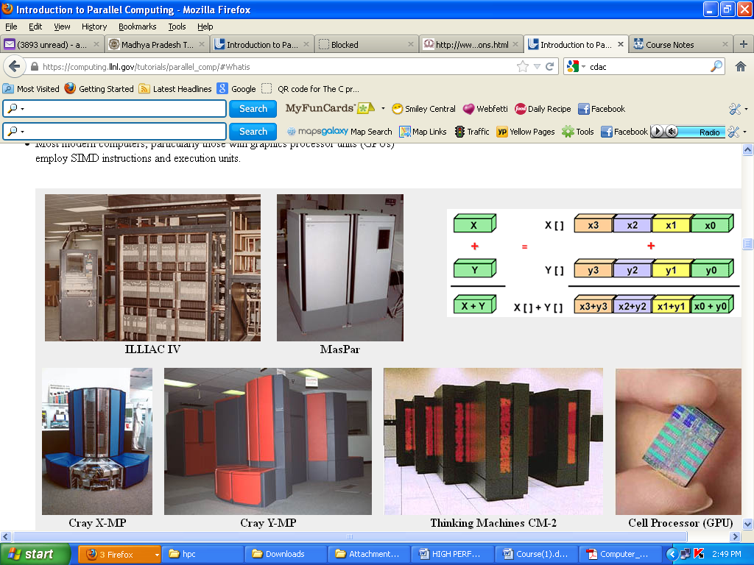

**3 Multiple Instruction, Single Data (MISD) computer organization**

There are n processor units, each receiving distinct instructions operating over the same data stream and its derivatives. The results of one processor become the input of the next processor in the macropipe.This structure has received much less attention and has been challenged as impractical by some computer architects.

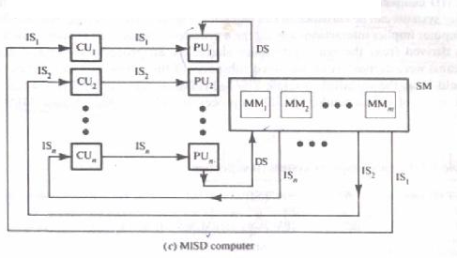

• A type of parallel computer

• **Multiple Instructions:** Each processing unit operates on the data independently via separate instruction streams.

• **Single Data:** A single data stream is fed into multiple processing units.

• Few actual examples of this class of parallel computer have ever existed. One is the experimental Carnegie-Mellon C.mmp computer (1971).

• Some conceivable uses might be:

* multiple frequency filters operating on a single signal stream
* multiple cryptography algorithms attempting to crack a single coded message

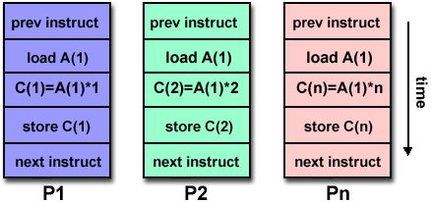

**4 Multiple Instruction, Multiple Data (MIMD) computer organization**

Most multiprocessor systems and multiple computer systems can be classified in this category. An intrinsic MIMD computer implies interactions among the n processors because all memory streams are derived from the same data space shared by all processors. If the n data streams were derived from disjointed subspaces of the shared memories, then we would have the so called multiple SISD operation, which is nothing but a set of n independent SISD uniprocesor systems.

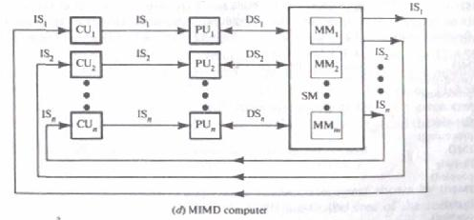

* A type of parallel computer
* **Multiple Instruction:** Every processor may be executing a different instruction stream
* **Multiple Data:** Every processor may be working with a different data stream
* Execution can be synchronous or asynchronous, deterministic or non-deterministic
* Currently, the most common type of parallel computer - most modern supercomputers fall into this category.
* Examples: most current supercomputers, networked parallel computer clusters and "grids", multi-processor SMP computers, multi-core PCs.
* Note: many MIMD architectures also include SIMD execution sub-components

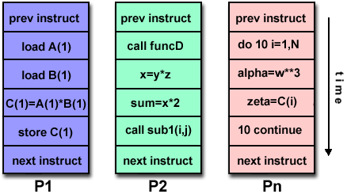

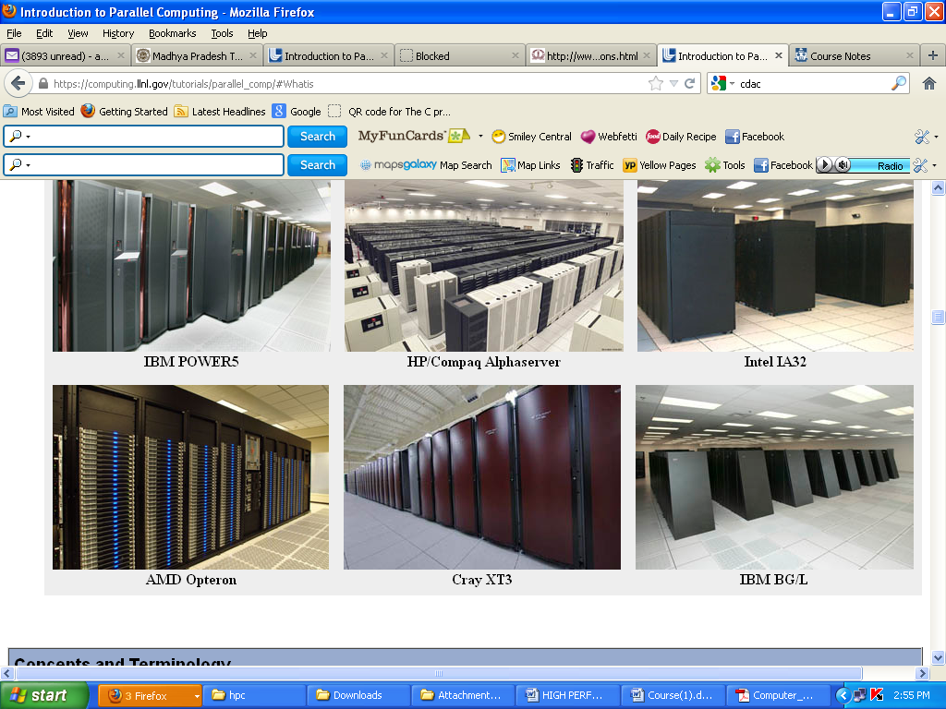

**1.5.2 FENG’s CLASSIFICATION( SERIAL VERSUS PARALLEL PROCESSING)**

According to Feng’s classification, computer architecture can be classified into four.

The classification is **based on the way contents stored in memory are processed**. The contents can be either data or instructions.

* Uses the concept of **degree of parallelism**.

The maximum number of binary digits that can be processed within a unit time by a computer system is called the maximum parallelism degree P.

The maximum parallelism degree P(C)of a given computer system C is represented by the product of the word length n and the bit slice length m;

**p(c)=n.m**

There are 4 types of processing methods.

1. **Word Serial Bit Serial (WSBS)-Bit serial processing**

One bit of one selected word is processed at a time. This represents serial processing and needs maximum processing time. This was done only in the first generation computers

1. **Word Serial Bit Parallel (WSBP)**

All bits of a selected word are processed at a time. Bit parallel means all bits of a word.

1. **Word Parallel Bit Serial (WPBS)**

One bit from all words are processed at a time. Word parallel signifies selection of all words.Found in most existing systems.Also called word slice processing.

1. **Word Parallel Bit Parallel (WPBP)**

All bits of all words are processed at a time. Maximum parallelism is achieved here.Fully parallel processing in which an array of n.m bits is processed at one time, the fastest processing mode of the four.

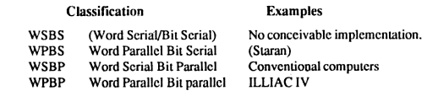

**1.5.3 HANDLER’s CLASSIFICATION( PARALLELISM VERSUS PIPELINING)**

* **Based on parallelism and pipelining implemented in the hardware structure of a computer.**

Wolfgang Handler has proposed a classification scheme for identifying the parallelism degree and pipelining degree built into the hardware structures of a computer system. He considers parallel pipeline processing at three subsystem levels

Processor Control unit (PCU)

Arithmetic logic unit (ALU)

Bit level circuit (BLC)

Here, PCU is the control unit for controlling one processor, ALU represents one processing element and BLC is the combinational circuit needed to process one bit.

The parallelism in a system can be explained using a triplet containing six independent entities, as defined below.

A computer C can be characterized by

**T(C) = < K X K’ ; D x D’ ; W x W’ >**

where,

K = the number of processor control units within the computer.

D = the number of ALU or processing elements under the control of one

PCU.

W = the word length of ALU or PE

K’ = the number of PCUs that can be pipelined.

D’ = the number of ALUs that can be pipelined.

W’= the number of pipelined stages on all ALUs or in a single PE.

Example: TI-ASC has one controller controlling four arithmetic units. Each ALU

is an eight stage pipeline with 64-bit word length.

It can be represented using Handler’s equation as:

T(TI-ASC)= <1 X1 ; 4 X 1; 64 X 8 >

**1.6 INDIAN CONTRIBUTIONS TO PARALLEL PROCESSING**

.

India has made significant strides in developing high-performance parallel computers .Many Indians feel that the presence of these systems has helped create a high-performance computing culture in India, and has brought down the cost of equivalent international machines in the Indian marketplace. However, questions remain about the cost-effectiveness of the government funding for these systems, and about their commercial viability

India’s government decided to support the development of indigenous parallel processing technology. In August 1988 it set up the Center for Development of Advanced Computing (C-DAC).

The C-DAC’s First Mission was to deliver a 1 -Gflop parallel supercomputer by 1991. Simultaneously, the Bhabha Atomic Research Center (BARC), the Advanced Numerical

Research & Analysis Group (Anurag) of the Defense Research and Development Organization, the National Aerospace Laboratory WAL) of the Council of Scientific and Industrial Research, and the Center for Development of Telematics (C-DOT) initiated complementary projects to develop high-performance parallel computers. Delivery of India’s firstgeneration parallel computers started in 199 1.

1. **Param**

The C-DAC’s computers are named Pairam (parallel machine), which means “supreme” in Sanskrit. The first Param systems, called the 8000 series, used Innios 800 and 805 Transputers as computing nodes.Although the theoretical peak-performance of a 256-node Param was 1 Gflop (a singlenode T805 performs at 4.25 Mflops), its sustained performance in an actual application turned out to be between 100 and 200 Mflops. The C-DAC named the programming environment Pavas, after the mythical stone that can turn iron into gold by mere touch.

Early in 1992, the C-DAC realized that the Param 8000’s basic compute node was underpowered, so it integrated Intel’s i860 chip into the Param architecture. The objective

was to preserve the same application programming environment and provide straightforward hardware upgrades by just replacing the Param 8000’s compute- node boards. This resulted in the Param 8600, architecture with the i860 as a main processor and four Transputers as communication processors, each with four built-in links. The *C*DAC extended Paras to the Param 8600 to give a user view identical to that of the Param 8000. Param 8000 applications could easily port to the new machine.

The C-DAC claimed that the sustained performance of the 16-node Param 8600 ranged from 100 to 200 Mflops, depending on the application. Both the C-DAC and the Indian government considered that the First Mission was accomplished and embarked on the Second Wssion, to deliver a teraflopsrange parallel system capable of addressing grand challenge problems. This machine, the Param 9000, was announced in 1994 and exhibited at Supercomputing ’94. The C-DAC plans to scale it to teraflops- level performance.

The Param 9000’s multistage interconnect network uses a packet-switching wormhole router as the basic switching element. Each switch can establish 32 simultaneous non blocking connections to provide a sustainable bandwidth of 320 Mbytes per second. The communication links conform to the IEEE P13 55 standards for point-to-point links. The Param 9000 architecture emphasizes flexibility. The C-DAC hopes that, as new technologies in processors, memory, and communication links become available, those elements can be upgraded in the field. The first system is the Param 9000/SS, which is based on SuperSparc processors. A complete node is a 75-MHz Supersparc I1 processor with 1 Mbyte of external cache, 16 to 12 8 Mbytes of memory, one to four communication links, and related I/O devices. When new MBus modules with higher frequencies become available, the computers can be field-upgraded. Users can integrate Sparc workstations into the Param 9000/SS by adding a Sbus-based network interface card. Each card supports one, two, or four communication links. The C-DAC also provides the necessary software drivers.

1. **Anupam**

The BARC, founded by Homi Bhabha and located in Bombay, is India’s major center for nuclear science and is at the forefront of India’s Atomic Energy Program. Through 1991 and 1992, BARC computer facility members started interacting with the C-DAC to develop a high-performance computing facility. The BARC estimated that it needed a machine of 200 Mflops sustained computing power to solve its problems. Because of the importance of the BARC’s program, it decided to build its own parallel computer. In 1992, the BARC developed the *Anupam* (Sanskrit for “unparalleled”) computer, based on the standard Multibus I1 i860 hardware. Initially, it announced an eight-node machine, which it expanded to 16, 24, and 32 nodes. Subsequently, the BARC transferred Anupam to the Electronics Corporation of India, which manufactures electronic systems under the umbrella of India’s Department of Atomic Energy.

**System Architecture**

Anupam has a multiple-instruction, multiple- data (MIMD) architecture realized through off-the-shelf Multibus I1 i860 cards and crates. Each node is a 64-bit i860 processor with a 64-Kbyte cache and a local memory of 16 to 64 Mbytes. A node’s peak computing power is 100 Mflops, although the sustained power is much less. The first version of the machine had eight nodes in a single cluster (or Multibus I1 crate). There is no need for a separate host. Anupam scales to 64 nodes. The intercluster message-passing bus is a 32-bit Multibus II backplane bus operating at 40 Mbytesls peak. Eight nodes in a cluster share this bus. Communication between clusters travels through two 16-bit-wide SCSI buses that form a 2D mesh. Standard topologies such as a mesh, ring, or hypercube can easily map to the mesh.

1. **PACE**

Anurag, located in Hyderabad, focuses on R&D in parallel computing; VLSIs; and applications of high-performance computing in computational fluid dynamics, medical imaging, and other areas. Anurag has developed the *Proces-* ***SOT*** *for Aevodynamzc Computations and Evaluatzon,* a loosely-coupled, messagepassing parallel processing system. The PACE program began in August 1988. The initial prototypes used the 16.67-MHz Motorola MC 68020 processor. The first prototype had four nodes and used a VME bus for communication. The VME backplane works well with Motorola processors and provided the necessary bandwidth and operational flexibility. Later, Anurag developed an eight-node prototype based on the 2s-MHz MC 68030. This cluster forms the backbone of the PACE architecture. The 128-node prototype is based on the 33-MHz MC 68030. To enhance the floating-point speed, Anurag has developed a floating-point processor, *Anuco.* The processor board has been specially designed to accommodate the MC 68881, MC 68882, or the Anuco floating-point accelerators. PACE+, the latest version, uses a 66- MHz HyperSparc node. The memory per node can expand to 256 MBytes.

1. **FLOSOLVER**

In 1986, the NAL, located in Bangalore, started a project to design, develop, and fabricate suitable parallel processing systems to solve fluid dynamics and aerodynamics problems. The project was motivated by the need for a powerful computer in the laboratory and was influenced by similar international developments *Florolver,* the NAL’s parallel computer, was the first operational Indian parallel computer. Since then, the NAL has built a series of updated versions, including Flosolver Mkl and MklA, four-processor systems based on 16-bit Intel 8086 and 8087 processors, Flosolver MklB, an eight-processor system, Flosolver Mk2, based on Intel’s 32-bit 80386 and 80387 processors, and the latest version, Flosolver Mk3, based on Intel’s 1860 RISC processor.

1. **Chipps**

The Indian government launched the *C*DOT to develop indigenous digital switching technology. The C-DOT, located in Bangalore, completed its First Mission in 1989 by delivering technologies for rural exchanges and secondary switching areas. In February 1988, the C-DOT signed a contract with the Department of Science and Technology to design and build a 640-Mflop, 1,000- MIPS-peak parallel computer. The *C*DOT set a target of 200 Mflops for sustained performance.

**System Architecture**

*C-DOTS High Perfomance Parallel Processing System* (Chipps) is based on the single-algorithm, multiple-data architecture. Such architecture provides coarse-grain parallelism with barrier synchronization, and uniform startup and simultaneous data distribution across all configurations. It also employs off-the-shelf hardware and software. Chipps supports large, medium, and small applications. The system has three versions: a 192-node, a 64-node, and a 16-node machine.

In terms of performance and software support, the Indian high-performance computers hardly compare to the best commercial machines. For example, the C-DAC’s 16-node Param 9000/SS has a peak performance of 0.96 Gflops, whereas Silicon Graphics’ 16-processor Power Challenge has a peak performance of 5.96 Gflops, and IBM’s 16- processor Para2 model 590 has a peak performance of 4.22 Gflops. However, the C-DAC hopes that a future Param based on DEC Alpha processors will match such performance.

**USES FOR PARALLEL COMPUTING**

* **Science and Engineering:** Historically, parallel computing has been considered to be "the high end of computing", and has been used to model difficult problems in many areas of science and engineering:

|  |  |  |  |
| --- | --- | --- | --- |
|  |  | * Atmosphere, Earth, Environment * Physics - applied, nuclear, particle, condensed matter, high pressure, fusion, photonics * Bioscience, Biotechnology, Genetics * Chemistry, Molecular Sciences * Geology, Seismology * Mechanical Engineering - from prosthetics to spacecraft * Electrical Engineering, Circuit Design, Microelectronics * Computer Science, Mathematics   Computer simulations |  |
|  |  | * **Industrial and Commercial:** Today, commercial applications provide an equal or greater driving force in the development of faster computers. These applications require the processing of large amounts of data in sophisticated ways. For example: * Databases, data mining * Oil exploration * Web search engines, web based business services * Medical imaging and diagnosis * P Financial and economic modeling * Management of national and multi-national corporations * Advanced graphics and virtual reality, particularly in the entertainment industry * Networked video and multi-media technologies * Collaborative work environments * harmaceutical design |  |

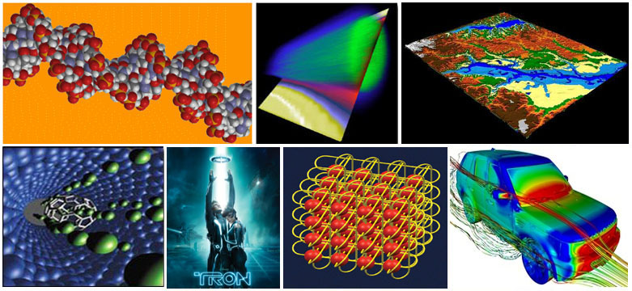

## Why Use Parallel Computing?

Main Reasons:

|  |  |
| --- | --- |
| **Save time and/or money:**  In theory, throwing more resources at a task will shorten its time to completion, with potential cost savings. Parallel computers can be built from cheap, commodity components. | https://computing.llnl.gov/tutorials/parallel_comp/images/timeMoney.jpg |
| **Solve larger problems:**  Many problems are so large and/or complex that it is impractical or impossible to solve them on a single computer, especially given limited computer memory. For example: | https://computing.llnl.gov/tutorials/parallel_comp/images/biggerProblems.jpg |
| **Provide concurrency:**  A single compute resource can only do one thing at a time. Multiple computing resources can be doing many things simultaneously. For example, the Access Grid provides a global collaboration network where people from around the world can meet and conduct work "virtually". | https://computing.llnl.gov/tutorials/parallel_comp/images/accessGrid.jpg |
| **Use of non-local resources:** Using compute resources on a wide area network, or even the Internet when local compute resources are scarce. | https://computing.llnl.gov/tutorials/parallel_comp/images/SETILogo.jpg |
|  |  |